Flying Insect Identification

If you have a swarm of honey bees, please locate a beekeeper near you on the swarm map and give them a call.

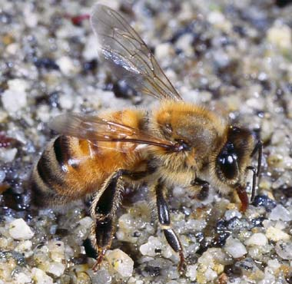

Honey Bee

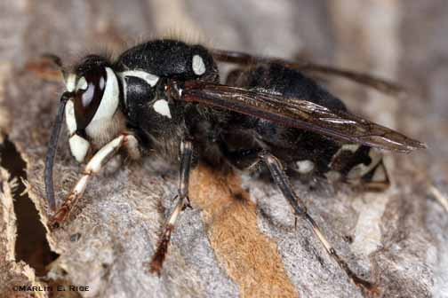

Bald Faced Hornet

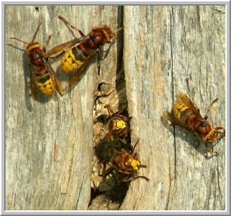

Hornet

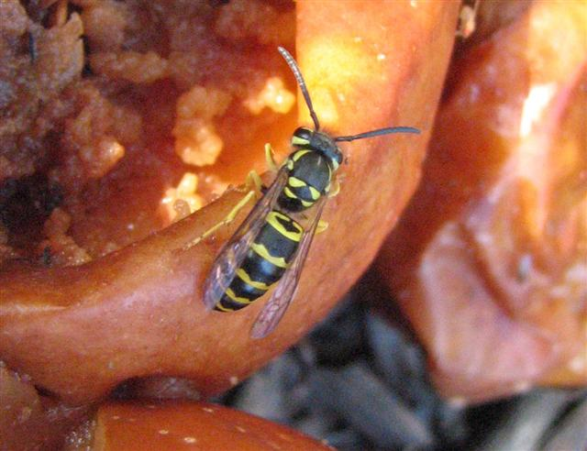

Yellow Jacket

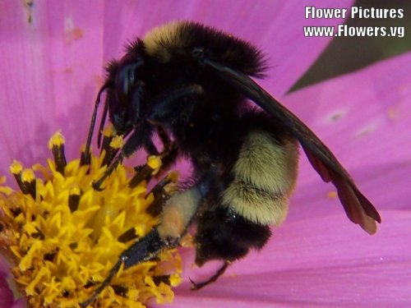

Bumble Bee

We are interested only in collecting the Honey Bee Swarms.

Not Hornets nest or Wasp nest.

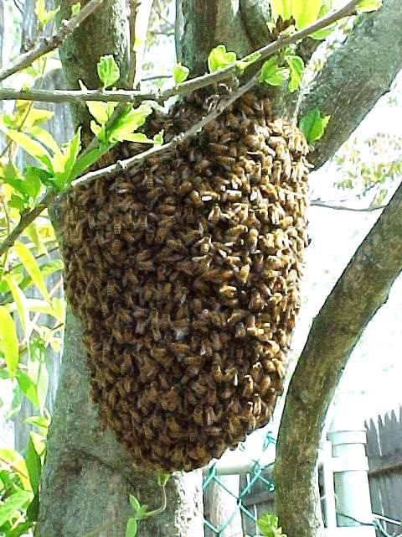

Honey Bee Swarm

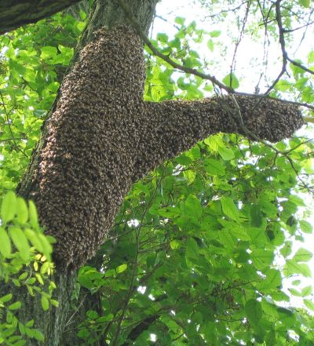

Honey Bee Swarm

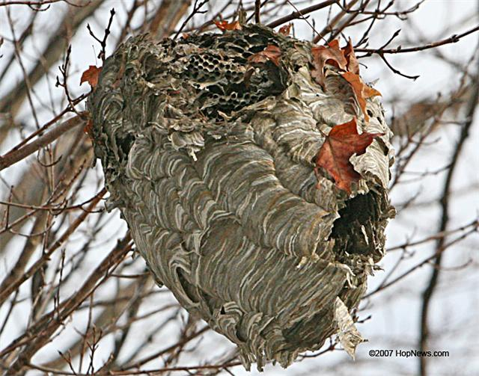

Hornet Nest

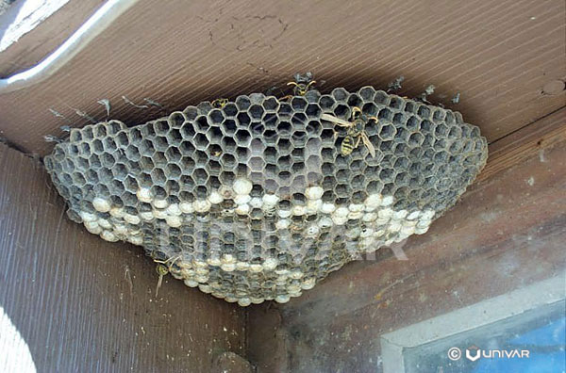

Wasp Nest

Pictures and text were provided by Mowbray Honey Farms
http://mowbrayhoneyfarm.com/honeybeeremoval.aspx

